
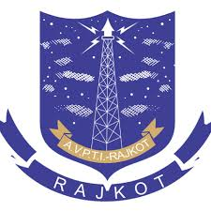
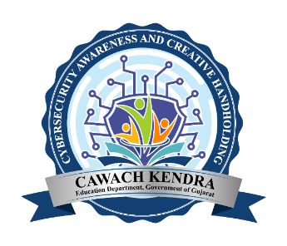

Seminar

on

“Awareness of Trending

Cyber Crimes”

Date: 30/01/2025

Under

CAWACH

(Cybersecurity Awareness and Creative Handhold Kendra)

In today's increasingly digital world, cybercrime has become one of the most prevalent and serious threats to individuals, organizations, and even governments. As more of our lives move online, the risks associated with cybercrime continue to rise. Cybercrime involves any illegal activity that uses a computer or the internet as a tool to commit the crime. This can include a wide range of activities, from hacking and identity theft to online scams and cyberbullying.
Cybercrime can have devastating consequences, including financial loss, identity theft, emotional distress, and damage to an individual’s or organization’s reputation. Raising awareness about cybercrime is crucial to equipping students with the knowledge and tools needed to protect themselves in the digital age.
Description of Event
With this aim, seminar on “Awareness of Trending Cyber Crimes” has been arranged on 30th January 2025 at A.V Parekh Technical Institute, Seminar hall- Computer Department, as a part of awareness campaign by CAWACH. The students got acquainted with the latest cybercrime incidents and scenarios making an individual prone to such cybercrimes. The precautionary measures and important helplines regarding various crimes were shared. One of the crimes namely “Social Media Crime” was demonstrated using a small skit performed by the students.

EVENT DETAILS:

NAME OF EVENT:– Seminar on “Awareness of Trending Cyber Crimes”
DATE: 30/01/2025
EVENT CORDINATOR: - Mrs. A.P Kurde
Outcome of Event:
Students became aware about latest cybercrimes prevailing huge damage to an individual and mass in society.

Total Number of Student attended | 66
Certificates to Skit performers | 7

