

DEPT. OF TECHNICAL EDUCATION (GOVT. OF GUJARAT)
Opp. Hemu Gadhavi Hall, Tagore Road, RAJKOT. Ph. (O)0281-2480175 Email: avpti1948@yahoo.com
--------------------------------------------------------------------------------------------------
Date:05/05/2025

COMPUTER ENGINEERING DEPARTMENT
EVENT REPORT
EVENT  DATE & TIME: | 05/05/2025 11:00 to 01:00
EVENT TYPE: | Curricular Activity
EVENT TITLE: | Guidance Session on DDCET Preparation
EVENT VENUE: | Seminar Hall, Computer Engineering Department
EVENT CO-ORDINATORS: | R.K. KADACHHA, V.J. PAMBHAR

RESOURCE PERSON DETAILS: | 6th Semester students and faculties of computer department.

NO. OF STUDENTS PARTICIPANTS (SEMESTER): | 35
NO. OF FACULTY PARTICIPANTS: | 08

ATTACHMENTS (Tick mark whatever applicable)
INVITATION LETTER | NA
EVENT NOTICE | YES
LETTER OF THANKS | NA
ATTENDANCE SHEET | YES
EXPERT FEEDBACK | NA

TOPIC HIGHLIGHTS | The department faculties will provide valuable suggestions and guidance regarding competitive exams, particularly focusing on the DDCET (Diploma to Degree CET).  In addition, 6th semester students will be sharing their personal experiences with the DDCET exam. They will discuss important aspects such as:  - How to effectively prepare for the DDCET exam.  - Recommended study materials and resources.  - Common mistakes to avoid during the exam.

EVENT OUTCOMES | 1.Students gain clarity about the structure, syllabus, and expectations of the DDCET exam.  2.Students learn effective study methods, recommended materials, and time management techniques.  3.By hearing from seniors, students become aware of mistakes to avoid during preparation and in the exam hall.  4.First-hand experiences from peers can ease anxiety and motivate students to begin focused preparation early.

EVENT PHOTOS:
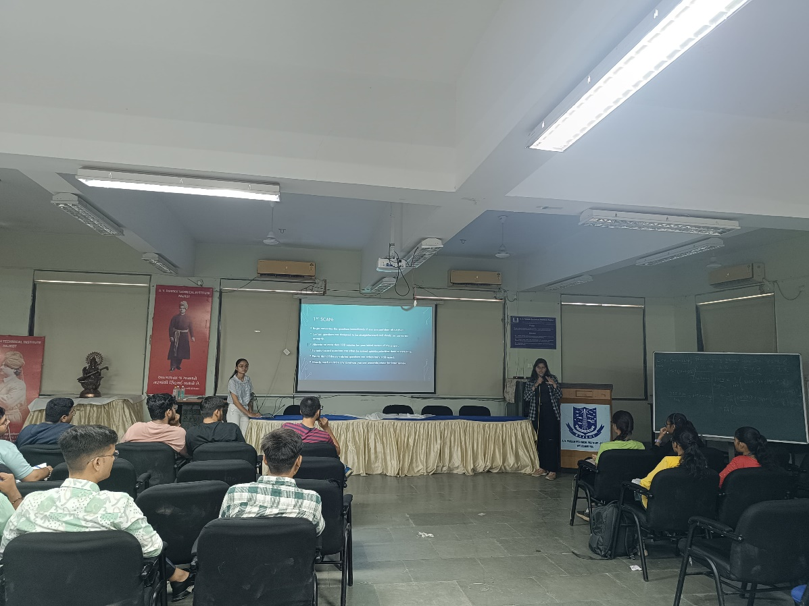
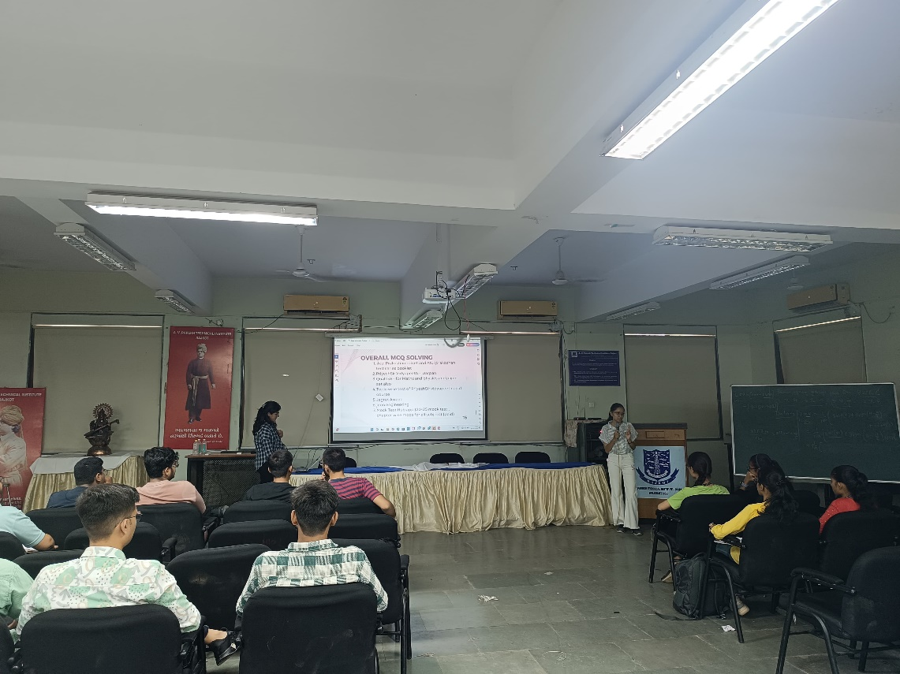

SIGNATURE
HEAD OF THE DEPARTMENT

